A341-ME- Syro-Hittite-Astarte-Figurine-Terracotta-Late Bronze Age-1500 - 1200 BCE

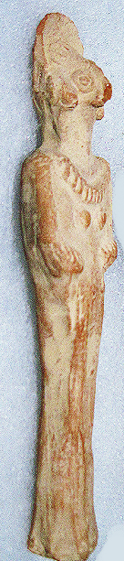 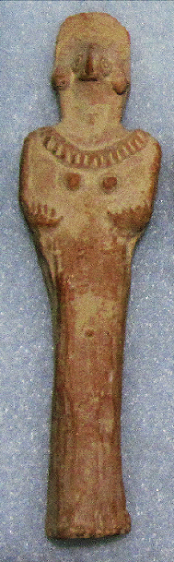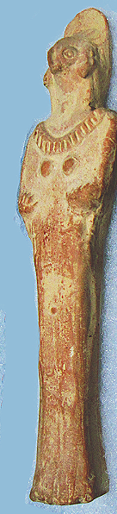

Figs. 1-3. Syro-Hittite-Astarte-Figurine-Terracotta-Late Bronze Age-1500 - 1200 BCE

**Case no.: 3**

**Accession Number: A341**

**Formal Label:** Syro-Hittite-Astarte-Figurine-Terracotta-Late Bronze Age-1500 - 1200 BCE

**Display Description:**

This stylized figurine with flat violin-shaped body and bird face with elaborate coiffure has two short arms tucked into its sides. An emphasized navel across the lower stomach area. Incised design decorates the torque around the neck (cf. Spycket, A., Borowski Collection, 2000, Cat. no. 84, p. 102, (photograph, p. 101), for the type with long arms; Keel, O., Freiburg, 2008, p. 23, fig 3).

**LC Classification:** BL1605 A5

**Date or Time Horizon:** Late Bronze Age-1500 - 1200 BCE

**Geographical Area:** N Syria, S Anatolia.

**Map, GPS coordinates:** N Syria, S Anatolia

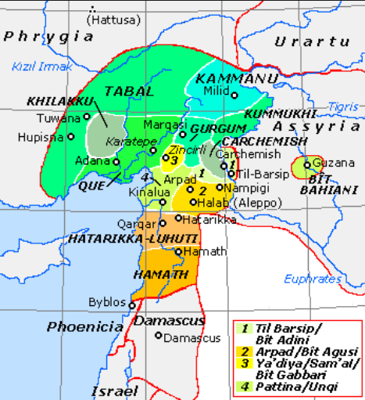

**Fig. 4.** Map of Luwian-, Aramaic- and Phoenician-speaking political entities of the Syro-Hittite states in northern Syria and southern Anatolia from https://upload.wikimedia.org/wikipedia/commons/f/fe/NeoHittiteStates.gif.

**Cultural Affiliation:** Syro-Hittite

**Medium:** terracotta

**Dimensions:** H. 13.4 cm., 5 1/4 in

**Weight:**

**Condition: original**

**Provenance:** Ex. Private Collection 1980's; Gideon Sasson, Sasson Ancient Art, King David Hotel - Annex, Jerusalem - 94101, Israel.

**Discussion:**

**References:**

Cornelius, Izak. 2004. *The many faces of the goddess: the iconography of the Syro-Palestinian goddesses Anat, Astarte, Qedeshe.* Fribourg, Switzerland: Academic Press; Göttingen: Vandenhoeck & Ruprecht.

Keel, O. 2008. *Gott weiblich: Eine verborgene Seite des biblischen Gottes, Gutersloher Verlagshaus*. Freiburg.

Spycket, A. 2000. *The Human Form Divine. From the Collection of Elie Borowski,* Exh. cat., Jerusalem: Bible Lands Museum.